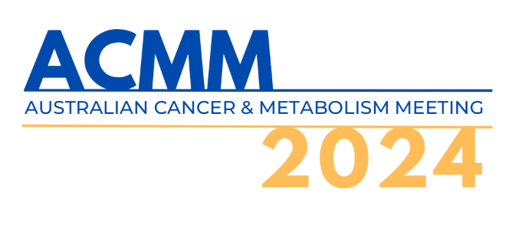
The 5th Australian Cancer & Metabolism Meeting (ACMM) will be held 15-17 May 2024 at the South Australian Health and Medical Research Institute (SAHMRI), North Tce, Adelaide.

ABSTRACT SUBMISSION TEMPLATE

Instructions
- Abstracts must be typed in English.
- Do not include tables, figures or references in your abstract submission.
- Ensure your abstract is thoroughly checked before finalising the submission as abstracts will be reproduced for review as submitted by the author.

Please complete the form below for submission and name the document with presenter surname_first name. eg: Smith_Jane.pdf Abstract Submission Closes: 5pm ACST Mon 1 Apr 2024.

Presenting Author Contact
First Name

Surname

Email

Mobile Phone Number |  |  |  |  | Country Code | +
Office Phone

Submitter Contact
Please only complete this section if you are submitting the abstract on behalf of the presenting author.
First Name

Surname

Email

Mobile Phone Number |  |  |  | Country Code |  |  | +
Session
Please indicate your preference of session type: |  |  | Seminar  Poster  No preference
Do you wish to be considered for a travel bursary?  Eligibility: bursaries are awarded to students and early-career researchers (< 5 years post-PhD) only. |  |  | Yes  No
Continues on next page
Abstract Submission Terms & Conditions
By submitting an abstract, you agree to the following:

- At least one author will register to attend and present at the Meeting.
- All authors whose abstracts have been accepted and who are presenting at the Meeting are responsible for all costs including registration, travel, accommodation, any costs associated with preparation and/or presentation of the abstract, or any other costs associated with attendance at the Meeting.
- All authors whose abstracts have been accepted and are presenting, must register for the Meeting by the close of early bird registration - see website for up-to-date details.
- If your abstract submission is accepted, you give ACMM permission to publish your abstract and related presentation materials and/or poster on the ACMM website and in the Meeting Program.
- You confirm that the abstract submission has been approved by all authors.
- The number of abstract submissions is not limited.

I agree with the Terms and Conditions: Yes No

Abstract Details
Title

Please avoid the use of brand/company names in the title.
Max 400 characters (inc. spaces).

Presenting Author |  | Presenting Author Name:  City:  State:  Post Code:  Country:
Continues on next page

Presenting Author Address  Please do not include department names.  Max 3 Institutions |  | Primary Institution Name:  City:  State:  Post Code:  Country:  ---  Secondary Institution Name (if any):  City:  State:  Post Code:  Country:  ---  Tertiary Institution Name (if any):  City:  State:  Post Code:  Country:
Continues on next page

All Author(s) Details

Please insert all author details in the table below (max 35 authors)

No. | Surname | Initial(s) | Primary Institution | City | Country
1
2
3
4
5
6
7
8
9
10
11
12
13
14
15
16
17
18
19
20
21
22
23
24
25
26
27
28
29
30
31
32
33
34
35

Continues on next page

Main Body Abstract:
Approx. 300 Words (Max. 2000 character limit inc spaces)
The abstract should be an informative document able to stand alone in its content and meaning.

The main body should be presented (where possible) under the following headings:
- Introduction.
- Methods.
- Results (do not include tables or figures).
- Conclusions.

The content must not have been previously published.

Terms must be spelt fully the first time they appear.

Conflict of Interest Statement
If the research described in the abstract was supported by a commercial company you must indicate the company's role in analysing the data or preparing the abstract.
This conflict-of-interest statement is mandatory for all abstracts submitted and where there is a conflict, this will appear wherever the abstracts are published. For abstracts accepted as an oral presentation, please ensure you include a slide disclosing the conflict of interest within your presentation.

Please complete the below:

I have no conflict of interest to disclose.

This research was supported by . The company had no role in analysing the data or preparing the abstract.

"This research was supported by . The company played a role in data analysis or abstract preparation as described here (describe the companies role in your research, analysis and abstract preparation): .

Abstract Acknowledgement
You will receive a confirmation email acknowledging receipt of your abstract submission. Once the panel has reviewed all abstracts, the Presenting Authors will be advised if their abstract/s have been accepted by email.

Submit your completed ACMM abstract via email to: pcmt@sahmri.com

