Omega-3 supplements for women with low omega-3 fatty acid status
Please see below, a list of commonly available supplements if you are ‘low’ in omega-3 (less than 3.7%) and your health professional has recommended taking omega-3 supplements (fish oil or algal oil) to reduce your risk of a premature birth. The suggested dose: 800 mg DHA and 100 mg EPA per day until 37 weeks gestation. All products are included on the Australian Register of Therapeutic Goods (ARTG) maintained by the Therapeutic Goods Administration (TGA): https://www.tga.gov.au/resources/australian-register-therapeutic-goods-artg.
Please note that this list is not exhaustive and SAHMRI does not endorse specific brands.
Suggested supplements and pricing as of 16-10-2025.

Supplement name | Image | Comments | Our suggested dose | DHA&EPA*  Omega-3 fatty acids (mg) | Price guide** | TGA link
Blackmores Omega Brain High DHA Fish Oil | 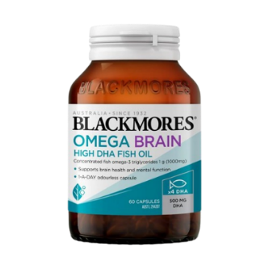 | Contains fish oil. Available in most pharmacies and can be ordered online: www.blackmores.com.au | Two capsules per day | DHA = 1000  EPA = 200 | $46.99 (60  capsules) | BLACKMORES OMEGA BRAIN HIGH DHA FISH OIL (294207) | Therapeutic Goods Administration (TGA)
Eagle Clinical Algal EPA DHA | 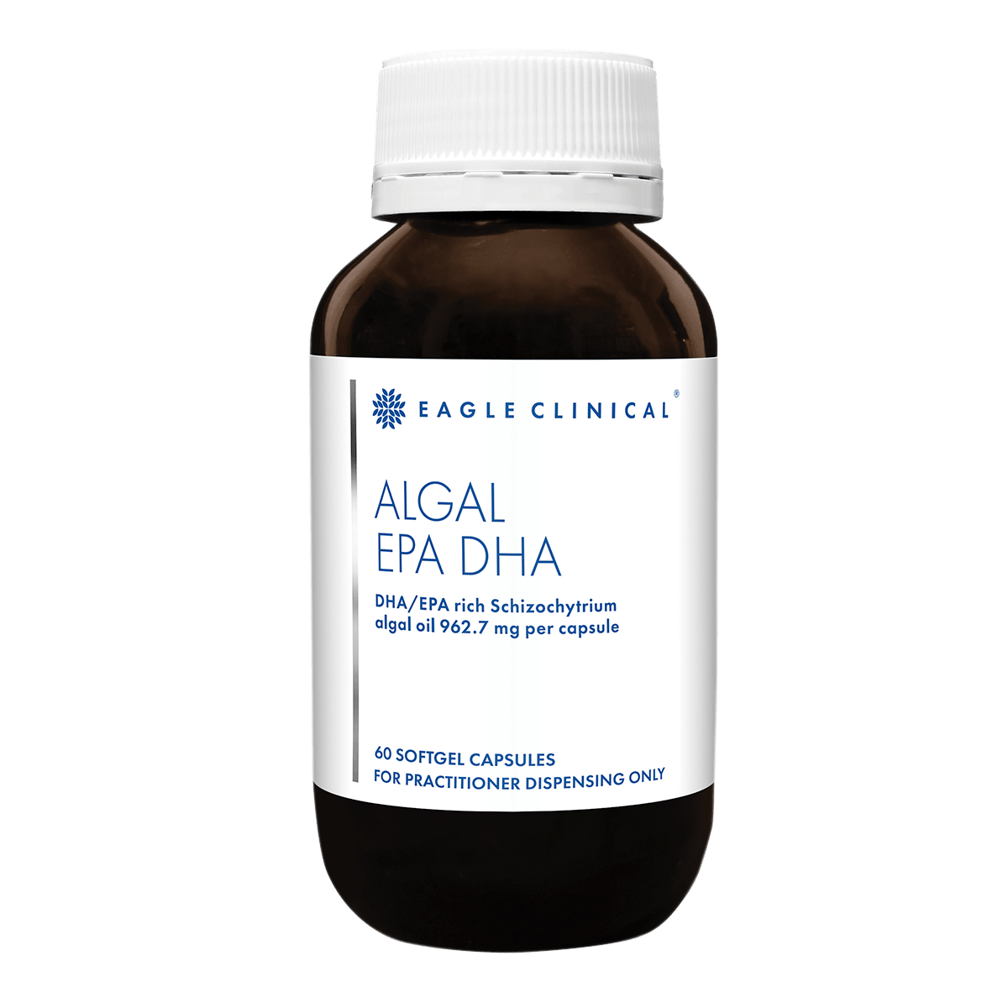 | Contains algal oil. Available online: Eagle Clinical Algal EPA/DHA – Betahealth | Two softgel capsules per day | DHA = 600  EPA = 300 | $129.95 (60 capsules) | Eagle Clinical Algal EPA DHA (448086) | Therapeutic Goods Administration (TGA)
Swisse Ultiboost Pregnancy DHA Fish Oil | 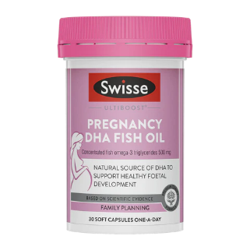 | Contains fish oil. Available online: https://swisse.com.au | Three soft capsules per day | DHA = 750  EPA = 150 | $44.99 (30 soft capsules) | Swisse Ultiboost Pregnancy DHA Fish Oil (392035) | Therapeutic Goods Administration (TGA)
*DHA&EPA, Docosahexaenoic acid & Eicosapentaenoic acid
**Recommended Retail Price if accessible (subject to change)

