Pregnancy supplements that do not contain omega-3 fatty acids

Please find a list of commonly available pregnancy supplements for women with ‘sufficient omega-3 status’ (greater than 4.3%) that do not contain omega-3 fatty acids. All products are included on the Australian Register of Therapeutic Goods (ARTG) maintained by the Therapeutic Goods Administration (TGA): https://www.tga.gov.au/resources/australian-register-therapeutic-goods-artg.

Please note that this list is not exhaustive and SAHMRI does not endorse specific brands.

Suggested supplements and pricing as of 16-10-2025.

Supplement name | Image | Our suggested  dose | Nutrients per suggested daily dose |  |  |  | Price guide**
Supplement name | Image | Our suggested  dose | DHA&EPA* Omega-3 fatty acids (mg) | Folic Acid (μg) | Vitamin D (IU) | Iodine  (μg) | Price guide**
Blackmores I-Folic | 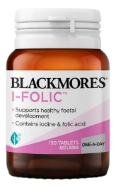 | One tablet daily | 0 | 500 | 0 | 150 | $24.99  (150 tablets)
Eagle Tresos Natal | 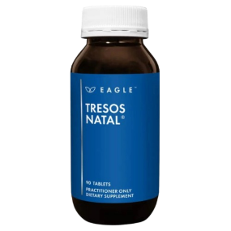 | One tablet daily | 0 | 250  (levomefolic acid or  5-MTHF) | 1000  (0.025mg colecalciferol) | 270 | $29.95  (30 tablets)  $49.99  (90 tablets)
Elevit Pre-conception & Pregnancy Multivitamin | 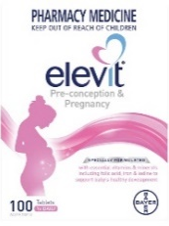 | One tablet daily | 0 | 400 | 1000  (0.025mg colecalciferol) | 220 | $32.99  (30 tablets)  $74.99  (100 tablets)
FabHealth FabFol | 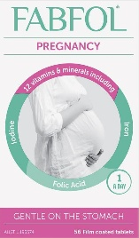 | One tablet daily | 0 | 500 | 200 | 150 | $28.50  (56 tablets)
Herbs of Gold Pregnancy Plus 1-2-3 | 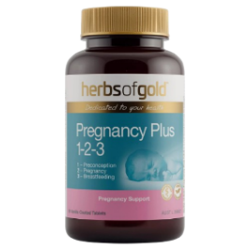 | One tablet twice daily | 0 | 250 | 1000  (0.0125mg colecalciferol per tablet) | 270 | $39.95  (60 tablets)
Metagenics Pregnancy Care Advanced | 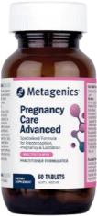 | One tablet twice daily | 0 | 400 | 1000  (0.0125mg colecalciferol per tablet) | 300 | $42.95  (60 tablets)
Mother Natal Complete Support | 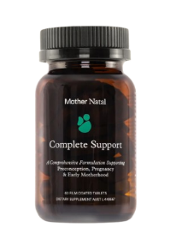 | Two tablets daily | 0 | 400 | 1000  (0.025mg colecalciferol) | 300 | $49.99  (60 tablets)
Natalis Pregnancy Support | 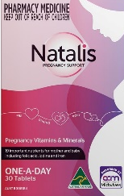 | One tablet daily | 0 | 800 | 200  (0.005mg colecalciferol) | 220 | $26.99  (30 tablets)
Naternal EverNatal | 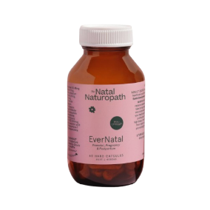 | Two capsules daily | 0 | 500  (levomefolic acid or 5-MTHF) | 1000 (0.025mg colecalciferol) | 270 | $55.99  (60 capsules)
Perdays Bump to Breast Prenatal Multi | 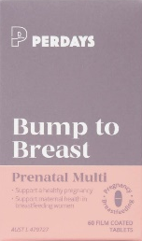 | Two tablets daily | 0 | 500  (levomefolic acid or 5-MTHF) | 500 | 0 | $45.00  (60 tablets)

*DHA&EPA, Docosahexaenoic acid & Eicosapentaenoic acid
**Recommended Retail Price if accessible (subject to change)

