Common pregnancy supplements with up to 250 mg DHA&EPA omega-3

fatty acids
Please find a list of commonly available supplements if you are ‘sufficient’ in omega-3 (over 4.3%) and already taking omega-3 fatty acids as part of a multivitamin and mineral. If you wish to continue omega-3 supplementation, the dose of DHA and EPA should not exceed 250mg per day. All products are included on the Australian Register of Therapeutic Goods (ARTG) maintained by the Therapeutic Goods Administration (TGA): https://www.tga.gov.au/resources/australian-register-therapeutic-goods-artg.
Please note that this list is not exhaustive and SAHMRI does not endorse specific brands.
Suggested supplements and pricing as of 16-10-2025.

Supplement name | Image | Comments | Our suggested dose | DHA&EPA* Omega-3 fatty acids (mg) | Price guide**
Blackmores  Conceive Well  Gold | 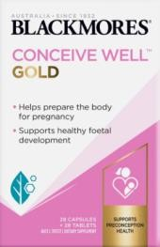 | Vit D and Omega 3 are in the capsule only | One capsule and one  tablet daily | Total = 150  DHA = 125  EPA = 25 | $47.99  (28 capsules + 28  tablets)
Blackmores  Pregnancy  Breast-Feeding  Gold | 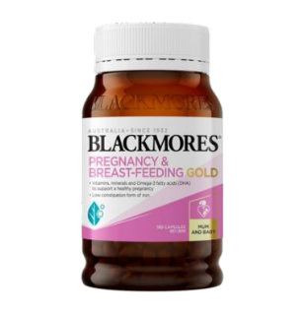 | One capsule daily fits the DHA&EPA* dose. The company suggested dose  exceeds the DHA&EPA* dose for women with sufficient omega-3. | One capsule daily | Total = 150  DHA = 125  EPA = 25 | $37.99  (60 capsules)
Elevit Breastfeeding | 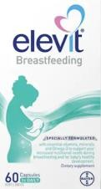 |  | One capsule daily | Total = 221  DHA = 200  EPA = 21 | $33.99  (30 capsules)  $49.99  (60 capsules)
Fefol Multi-Preg Liquid Cap | 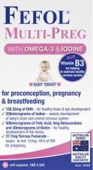 |  | One capsule daily | Total = 196.37  DHA = 159.32  EPA = 37.05 | $34.95  (60 capsules)

*DHA&EPA, Docosahexaenoic acid & Eicosapentaenoic acid

**Recommended Retail Price if accessible (subject to change)

